6.PROJECT TESTING PHASE

Project Executions:

· Install Postman or ThunderClient (VS Code extension).

· Start the backend server:
“npm start”

API Testing
User Registration :

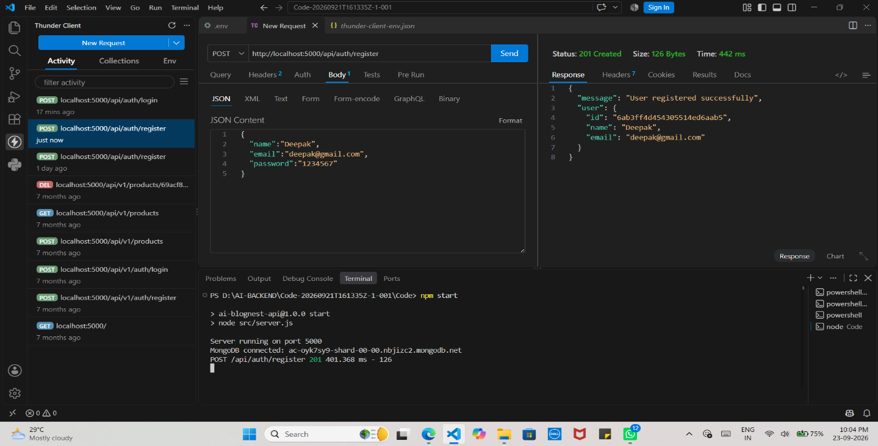
User Login:
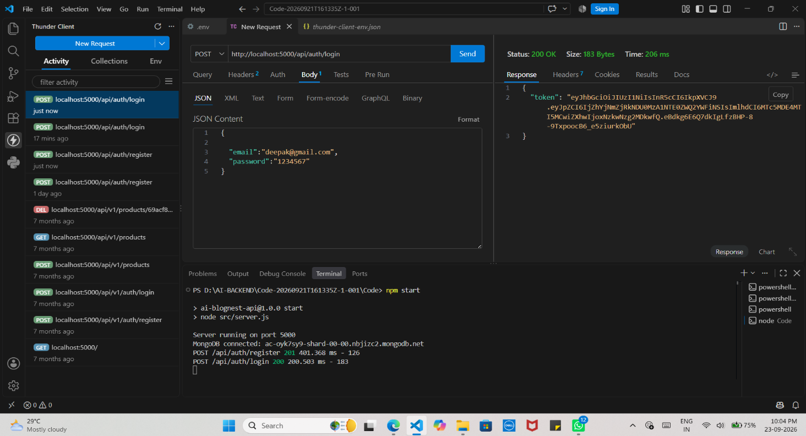

Create Blogs :

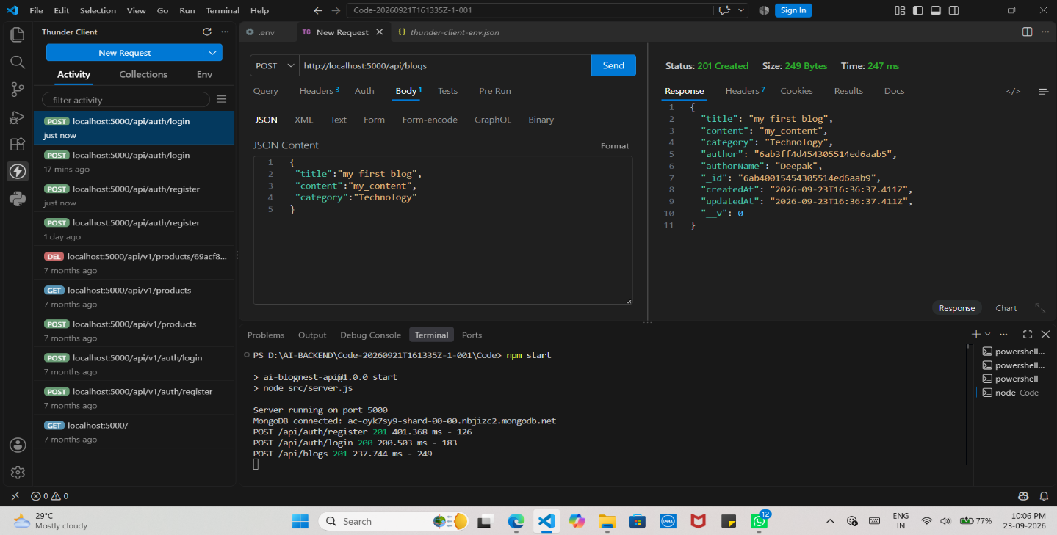

Fetch Blogs :

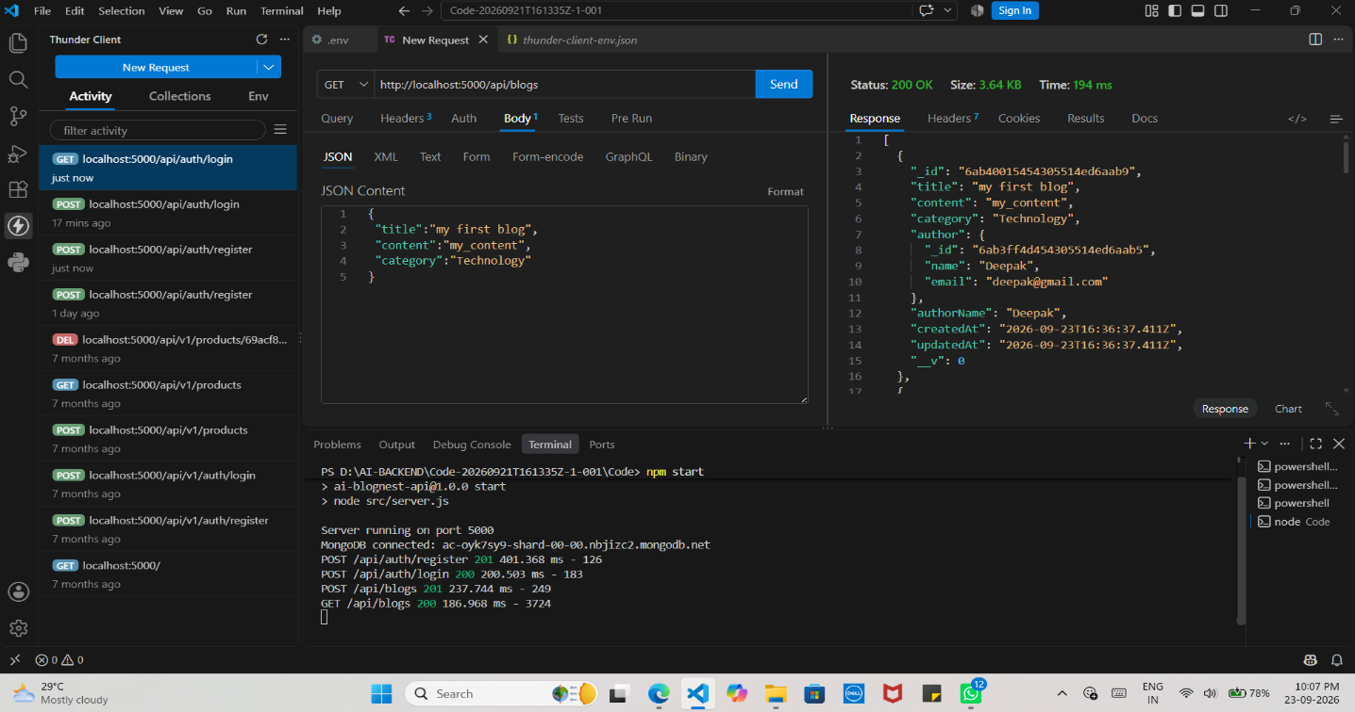

Generate AI blogs :

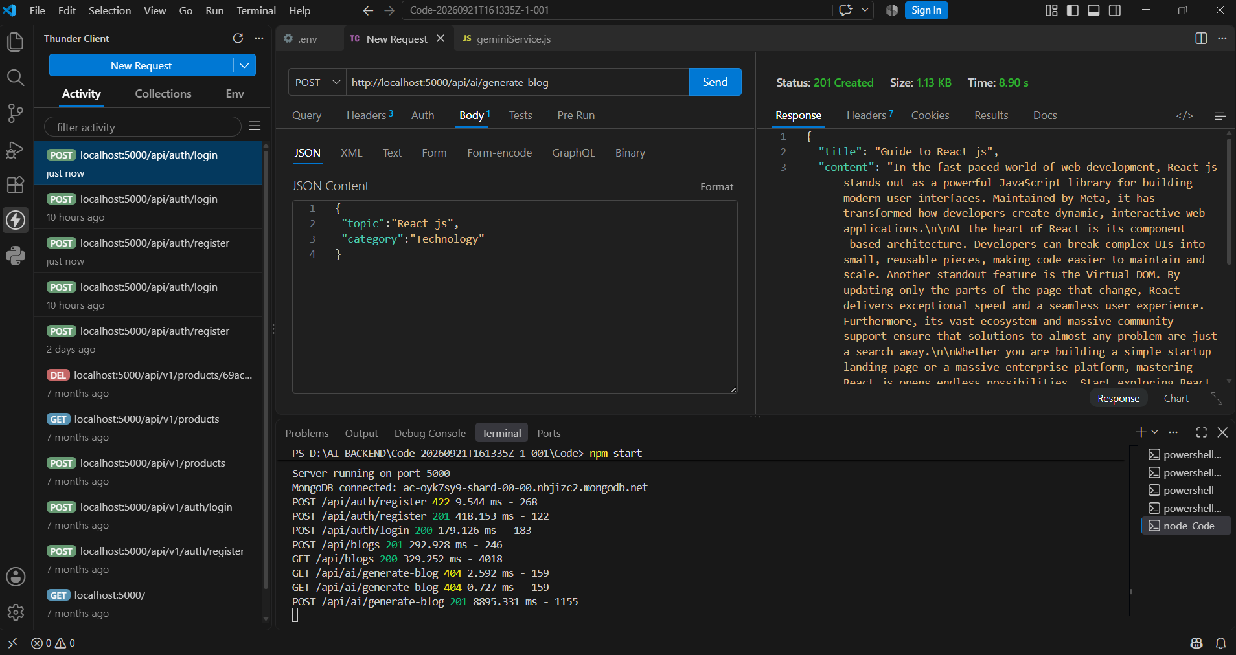
Summarize Blogs :

